Git Bash

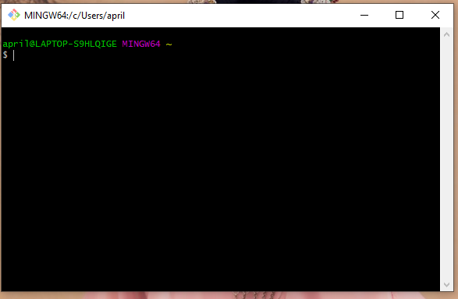

Python 3

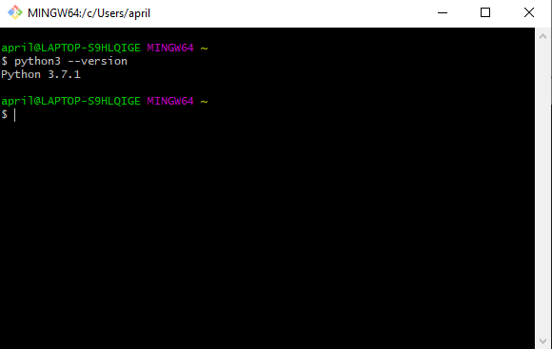

Jupter Notebook

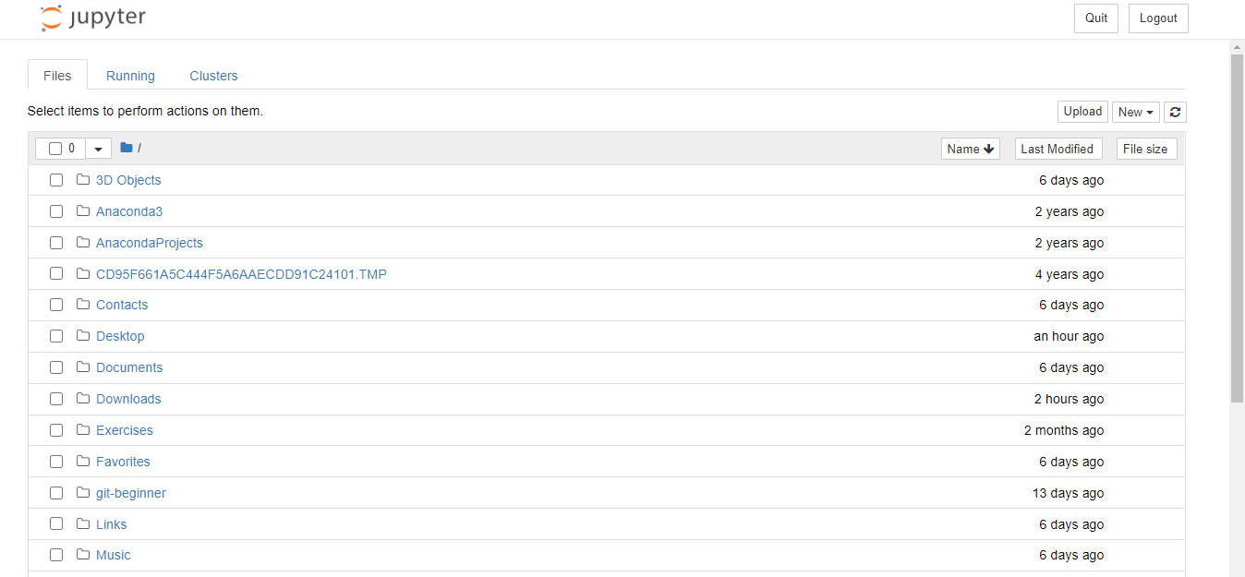

SQL

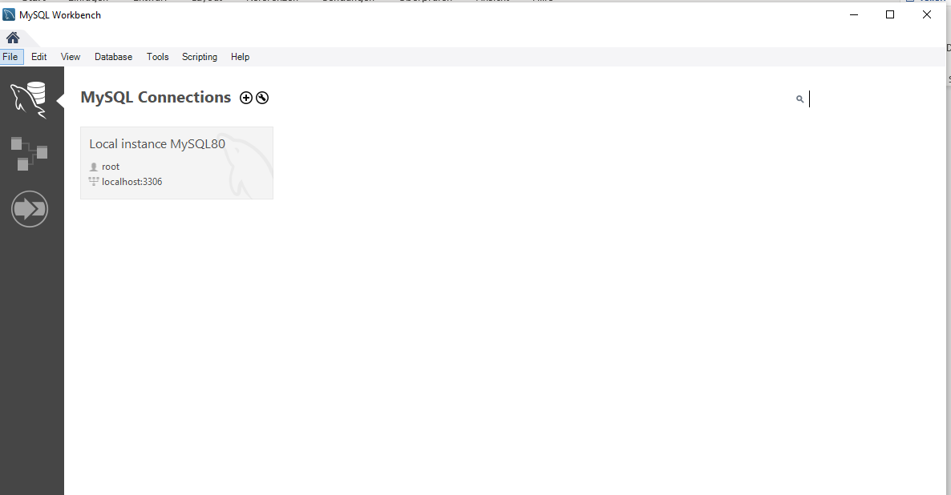

I installed them but I have the following difficulties which I don’t know how to solve them yet:

1. I cannot connect mySQL to the server
2. I cannot start mySQL through git bash
3. I cannot access Python from command lien